COGNIZANT CODE CAFÉ:-

Db:indexeddb

Framework:angular js,html5,materializecss

**#ACTUAL PAGE:-**

**Open mainpage.html**

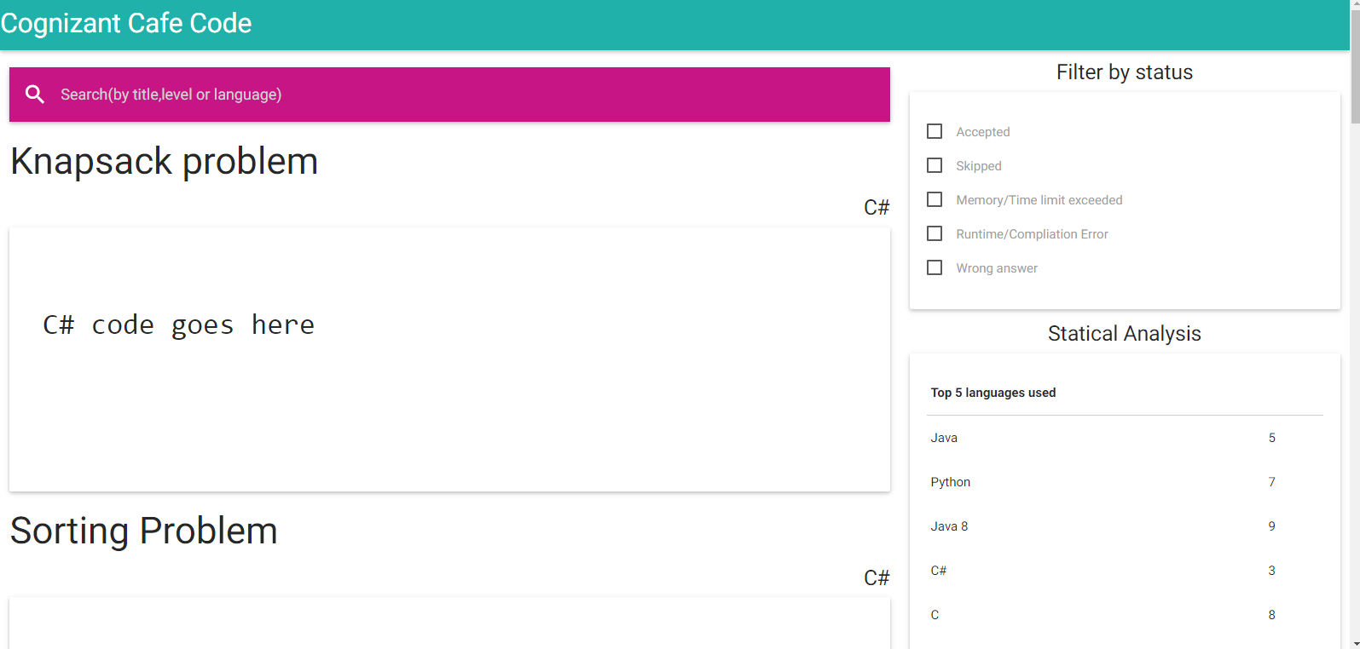

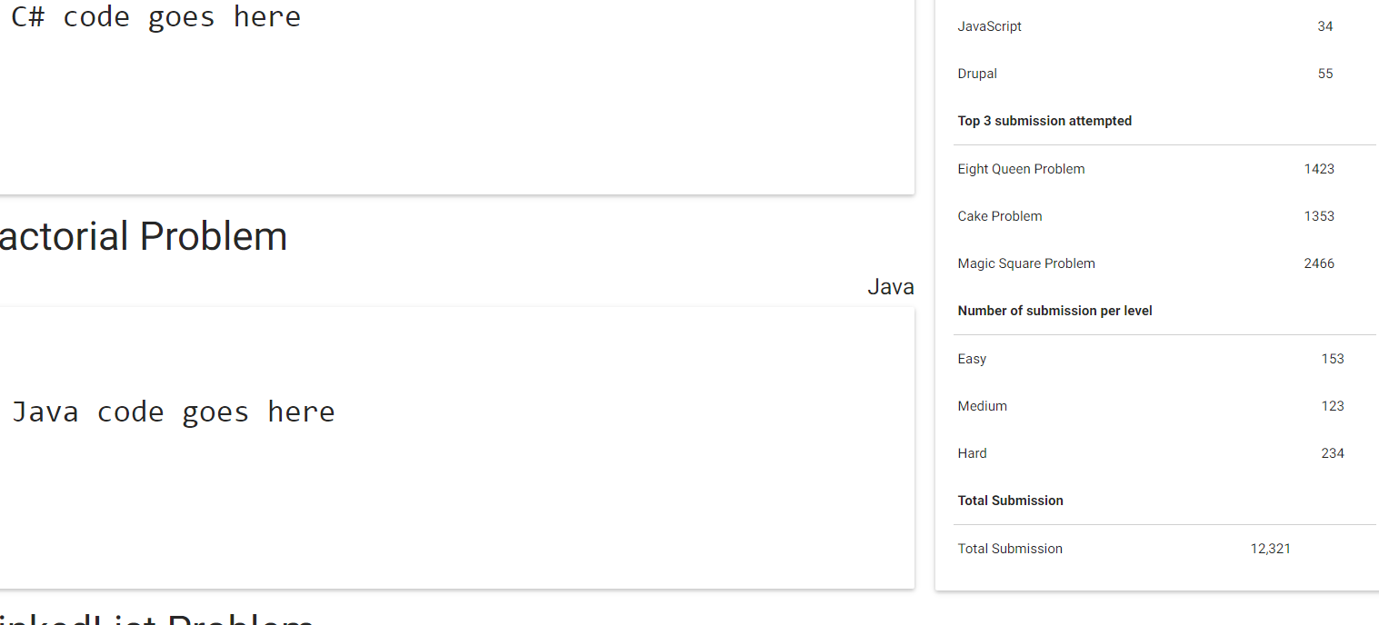

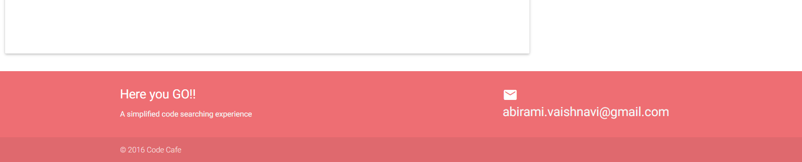

**#SAMPLE PAGE:-**

**sample.html**

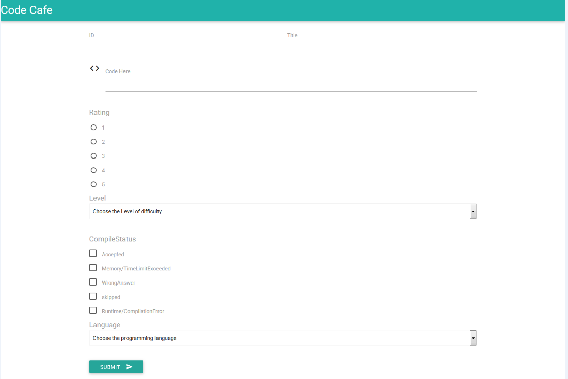

**#Create entries in DB**

**Open index.html and click add.**

